

2026 INFLUENZA VACCINE THE BEST PROTECTION FOR A SAFE & HEALTHY WORKPLACE FOR YOUR STAFF
The 2026 Flu Vaccine will protect against the WHO Recommended circulating strains of the influenza virus

A/Missouri/11/2025 (H1N1) pdm09-like strain
A/Singapore/GP20238/2024 (H3N2)-like strain
B/Austria/1359417/2021-like strain
B/Phuket/3073/2013-like strain
https://www.immune.org.nz/diseases/influenza
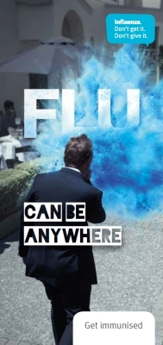

- Can you afford to have staff off work with influenza? Be proactive in your management of absenteeism.

- Vaccinations at your site or at our BHS rooms.

- Need help scheduling /online booking - we can help & ensure you get a fast, efficient service, with minimal work disruption

- BHS Vaccinators are Qualified Ministry of Health Approved vaccinators for the Workplace’

- Flu vouchers available nationwide- useful for those off site staff or away on day of vaccinations

Influenza can cause disruption in the workplace, e.g., absenteeism or impaired employee performance from illness.
Influenza is highly contagious and tends to occur in epidemics (i.e. spreads rapidly), by protecting yourself you can also keep your family safe from illness
Flu vaccines are given on a voluntary basis to staff
Vaccinations are required annually to ensure protection and should be given prior to the winter months in April/May/June to provide effective cover for the risk period.

Cost per person + gst from $32 and discount based on numbers
Fluad for the 50+ age range (specifically for older people & optional )

- After hours fees may apply for visits on site & any travel time/Mileage if required will be quoted in advance

ONLINE BOOKING SYSTEM AVAILABLE

VOUCHERS: BHS can provide vouchers for staff who cannot attend on the day or work remotely. Redeemable at most Unichem & Life Pharmacies throughout

To order, please phone or email : office@bhs.net.nz p 823 8406 Wendy Spence 021976509
Company Name: __________________________________Contact Person: _____________________________
Address: _________________________________________Ph & Email address: _________________________
Number of vaccines (approx.) __________________________________________________________________

